Have been using keras and TensorFlow for a while now – and love its simplicity and straight-forward way to modeling. As part of the latest update to my [workshop](https://shirinsplayground.netlify.com/2018/05/deep_learning_keras_tensorflow_18_07/) about deep learning with R and keras I've added a new example analysis such as Building an image classifier to differentiate different types of fruits.

**The code**

library(keras)

The dataset is the [fruit images dataset from Kaggle](https://www.kaggle.com/moltean/fruits/data). I downloaded it to my computer and unpacked it. Because I don't want to build a model for all the different fruits, I define a list of fruits (corresponding to the folder names) that I want to include in the model.

I also define a few other parameters, in the beginning, to make adapting as easy as possible.

# list of fruits to modle

fruit_list <- c("Kiwi", "Banana", "Apricot", "Avocado", "Cocos", "Clementine", "Mandarine", "Orange",

"Limes", "Lemon", "Peach", "Plum", "Raspberry", "Strawberry", "Pineapple", "Pomegranate")

# number of output classes (i.e. fruits)

output_n <- length(fruit_list)

# image size to scale down to (original images are 100 x 100 px)

img_width <- 20

img_height <- 20

target_size <- c(img_width, img_height)

# RGB = 3 channels

channels <- 3

# path to image folders

train_image_files_path <- "/Users/shiringlander/Documents/Github/DL_AI/Tutti_Frutti/fruits-360/Training/"

valid_image_files_path <- "/Users/shiringlander/Documents/Github/DL_AI/Tutti_Frutti/fruits-360/Validation/"

**Loading images**

The handy image_data_generator() and flow_images_from_directory() functions can be used to load images from a directory. If you want to use data augmentation, you can directly define how and in what way you want to augment your images with image_data_generator. Here I am not augmenting the data, I only scale the pixel values to fall between 0 and 1.

# optional data augmentation

train_data_gen = image_data_generator(

rescale = 1/255 #,

#rotation_range = 40,

#width_shift_range = 0.2,

#height_shift_range = 0.2,

#shear_range = 0.2,

#zoom_range = 0.2,

#horizontal_flip = TRUE,

#fill_mode = "nearest"

)

# Validation data shouldn't be augmented! But it should also be scaled.

valid_data_gen <- image_data_generator(

rescale = 1/255

)

Now we load the images into memory and resize them.

# training images

train_image_array_gen <- flow_images_from_directory(train_image_files_path,

train_data_gen,

target_size = target_size,

class_mode = "categorical",

classes = fruit_list,

seed = 42)

# validation images

valid_image_array_gen <- flow_images_from_directory(valid_image_files_path,

valid_data_gen,

target_size = target_size,

class_mode = "categorical",

classes = fruit_list,

seed = 42)

cat("Number of images per class:")

## Number of images per class:

table(factor(train_image_array_gen$classes))

*## 0 1 2 3 4 5 6 7 8 9 10 11 12 13 14 15*

*## 466 490 492 427 490 490 490 479 490 492 492 447 490 492 490 492*

cat("\nClass label vs index mapping:\n")

## Class label vs index mapping:

train_image_array_gen$class_indices

*## $Lemon*

*## [1] 9*

*##*

*## $Peach*

*## [1] 10*

*##*

*## $Limes*

*## [1] 8*

*##*

*## $Apricot*

*## [1] 2*

*##*

*## $Plum*

*## [1] 11*

*##*

*## $Avocado*

*## [1] 3*

*##*

*## $Strawberry*

*## [1] 13*

*##*

*## $Pineapple*

*## [1] 14*

*##*

*## $Orange*

*## [1] 7*

*##*

*## $Mandarine*

*## [1] 6*

*##*

*## $Banana*

*## [1] 1*

*##*

*## $Clementine*

*## [1] 5*

*##*

*## $Kiwi*

*## [1] 0*

*##*

*## $Cocos*

*## [1] 4*

*##*

*## $Pomegranate*

*## [1] 15*

*##*

*## $Raspberry*

*## [1] 12*

fruits_classes_indices <- train_image_array_gen$class_indices

save(fruits_classes_indices, file = "/Users/shiringlander/Documents/Github/DL_AI/Tutti_Frutti/fruits-360/fruits_classes_indices.RData")

**Define model**

Next, we define the keras model.

# number of training samples

train_samples <- train_image_array_gen$n

# number of validation samples

valid_samples <- valid_image_array_gen$n

# define batch size and number of epochs

batch_size <- 32

epochs <- 10

The model I am using here is a very simple sequential convolutional neural net with the following hidden layers: 2 convolutional layers, one pooling layer and one dense layer.

# initialise model

model <- keras_model_sequential()

# add layers

model %>%

layer_conv_2d(filter = 32, kernel_size = c(3,3), padding = "same", input_shape = c(img_width, img_height, channels)) %>%

layer_activation("relu") %>%

# Second hidden layer

layer_conv_2d(filter = 16, kernel_size = c(3,3), padding = "same") %>%

layer_activation_leaky_relu(0.5) %>%

layer_batch_normalization() %>%

# Use max pooling

layer_max_pooling_2d(pool_size = c(2,2)) %>%

layer_dropout(0.25) %>%

# Flatten max filtered output into feature vector

# and feed into dense layer

layer_flatten() %>%

layer_dense(100) %>%

layer_activation("relu") %>%

layer_dropout(0.5) %>%

# Outputs from dense layer are projected onto output layer

layer_dense(output_n) %>%

layer_activation("softmax")

# compile

model %>% compile(

loss = "categorical_crossentropy",

optimizer = optimizer_rmsprop(lr = 0.0001, decay = 1e-6),

metrics = "accuracy"

)

Fit the model; because I used image_data_generator() and flow_images_from_directory() I am now also using the fit_generator() to run the training.

# fit

hist <- model %>% fit_generator(

# training data

train_image_array_gen,

# epochs

steps_per_epoch = as.integer(train_samples / batch_size),

epochs = epochs,

# validation data

validation_data = valid_image_array_gen,

validation_steps = as.integer(valid_samples / batch_size),

# print progress

verbose = 2,

callbacks = list(

# save best model after every epoch

callback_model_checkpoint("/Users/shiringlander/Documents/Github/DL_AI/Tutti_Frutti/fruits-360/keras/fruits_checkpoints.h5", save_best_only = TRUE),

# only needed for visualising with TensorBoard

callback_tensorboard(log_dir = "/Users/shiringlander/Documents/Github/DL_AI/Tutti_Frutti/fruits-360/keras/logs")

)

)

In RStudio we are seeing the output as an interactive plot in the “Viewer” pane but we can also plot it:

plot(hist)

Gives this plot:  
[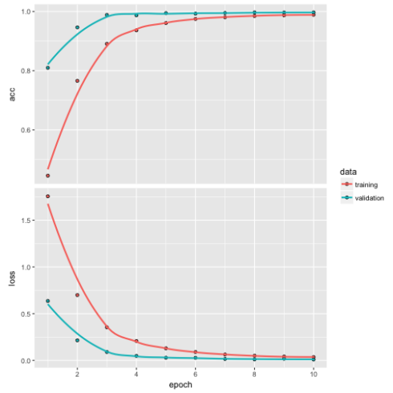](https://datascienceplus.com/wp-content/uploads/2018/06/unnamed-chunk-10-1.png)

As we can see, the model is quite accurate on the validation data. However, we need to keep in mind that our images are very uniform, they all have the same white background and show the fruits centered and without anything else in the images. Thus, our model will not work with images that don't look similar as the ones we trained on (that's also why we can achieve such good results with such a small neural net).

Finally, I want to have a look at the TensorFlow graph with TensorBoard.

tensorboard("/Users/shiringlander/Documents/Github/DL_AI/Tutti_Frutti/fruits-360/keras/logs")

[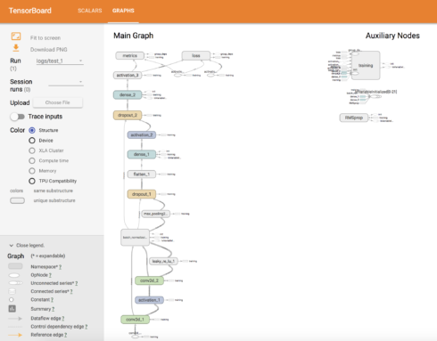](https://datascienceplus.com/wp-content/uploads/2018/06/tensorboard.png)

That's all there is to it!

Of course, you could now save your model and/or the weights, visualize the hidden layers, run predictions on test data, etc. For now, I'll leave it at that, though.

sessionInfo()

*## R version 3.5.0 (2018-04-23)*

*## Platform: x86_64-apple-darwin15.6.0 (64-bit)*

*## Running under: macOS High Sierra 10.13.5*

*##*

*## Matrix products: default*

*## BLAS: /System/Library/Frameworks/Accelerate.framework/Versions/A/Frameworks/vecLib.framework/Versions/A/libBLAS.dylib*

*## LAPACK: /Library/Frameworks/R.framework/Versions/3.5/Resources/lib/libRlapack.dylib*

*##*

*## locale:*

*## [1] de_DE.UTF-8/de_DE.UTF-8/de_DE.UTF-8/C/de_DE.UTF-8/de_DE.UTF-8*

*##*

*## attached base packages:*

*## [1] stats graphics grDevices utils datasets methods base*

*##*

*## other attached packages:*

*## [1] keras_2.1.6 knitr_1.20 RWordPress_0.2-3*

*##*

*## loaded via a namespace (and not attached):*

*## [1] Rcpp_0.12.17 highr_0.7 pillar_1.2.3 compiler_3.5.0*

*## [5] plyr_1.8.4 bitops_1.0-6 base64enc_0.1-3 tools_3.5.0*

*## [9] zeallot_0.1.0 digest_0.6.15 tibble_1.4.2 jsonlite_1.5*

*## [13] evaluate_0.10.1 gtable_0.2.0 lattice_0.20-35 rlang_0.2.1*

*## [17] Matrix_1.2-14 yaml_2.1.19 blogdown_0.6 xfun_0.2*

*## [21] stringr_1.3.1 rprojroot_1.3-2 grid_3.5.0 reticulate_1.8*

*## [25] R6_2.2.2 XML_3.98-1.11 rmarkdown_1.10 bookdown_0.7*

*## [29] reshape2_1.4.3 ggplot2_2.2.1 magrittr_1.5 whisker_0.3-2*

*## [33] backports_1.1.2 XMLRPC_0.3-0 scales_0.5.0 htmltools_0.3.6*

*## [37] tfruns_1.3 colorspace_1.3-2 labeling_0.3 tensorflow_1.8*

*## [41] stringi_1.2.3 RCurl_1.95-4.10 lazyeval_0.2.1 munsell_0.5.0*